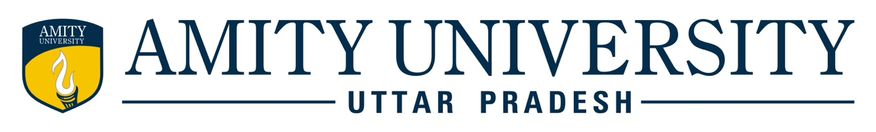

AMITY SCHOOL OF ENGINEERING & TECHNOLOGY
DEPARTMENT OF INFORMATION TECHNOLOGY

WEEKLY PROGRESS REPORT (WPR)

For the week commencing on15/09/2025 -21/09/2025

Program: B. Tech (Information Technology)

Batch: 2022-2026

Student Name: Sarthak Jha

Enrolment Number: A2305322060

Faculty Guide: Dr Saru Dhir
Project Title: Integrating diverse medical datasets ensuring data privacy and compliance

Targets set for the week:
1. Develop an Emergency SOS system for patient emergencies.
2. Implement SOS features such as WhatsApp-based location sharing, emergency contacts notification, and medical info integration.
3.Ensure compliance with privacy and security protocols while handling sensitive emergency data.

Progress/Achievements for the week:
1.Successfully developed and integrated the Emergency SOS system into the platform.
2.Linked SOS with WhatsApp for live location sharing, enabling real-time tracking during emergencies.
3.Configured emergency contact alerts to notify registered family members and hospitals instantly.
4.Integrated support for sharing medical details (blood group, allergies, prescriptions) along with location data.

Future Work Plans:

1Perform end-to-end testing of the SOS system with other modules (Live Bed Map, Doctor Switch, Insurance).
2.Optimize SOS notifications for faster response times.
3.Collect feedback from test users on usability and responsiveness.
4.Prepare for integration into the hospital dashboard and ambulance services for real-world simulation.

